

MATHEMATICS
APPLICATIONS

Test 2 – Linear Models and Sequences

Chapters 2 and 3
Semester 1 2017

Section One - Calculator Free

Time allowed for this section
Working time for this section: 30 minutes
Marks available: 32 marks

Material required/recommended for this section

To be provided by the supervisor
This Question/Answer booklet
Formula sheet

To be provided by the candidate
Standard items: pens, pencils, pencil sharpener, eraser, correction fluid, ruler, highlighters

Special items: Nil

Important note to candidates
No other items may be used in this section of the examination. It is your responsibility to ensure that you do not have any unauthorised notes or other items of a non-personal nature in the examination room. If you have any unauthorised material with you, hand it to the supervisor before reading any further.

- (3 marks)
Calculate the sum of all the multiples of 5 between 1 and 50.

- (4 marks: 2, 2)
Below are four consecutive numbers of an arithmetic sequence. The middle two numbers are missing.
22, ……. , ……. , 76
- What are the two missing numbers?

b) Determine the general rule for T_{n}

- (3 marks: 1, 2)
For the sequence, −4, 32, −256, ...
- Find the common ratio

- Determine the rule for the n^{th} term

- (7 marks: 1, 1, 1, 2, 2)
The terms of a sequence are shown in the graph below.
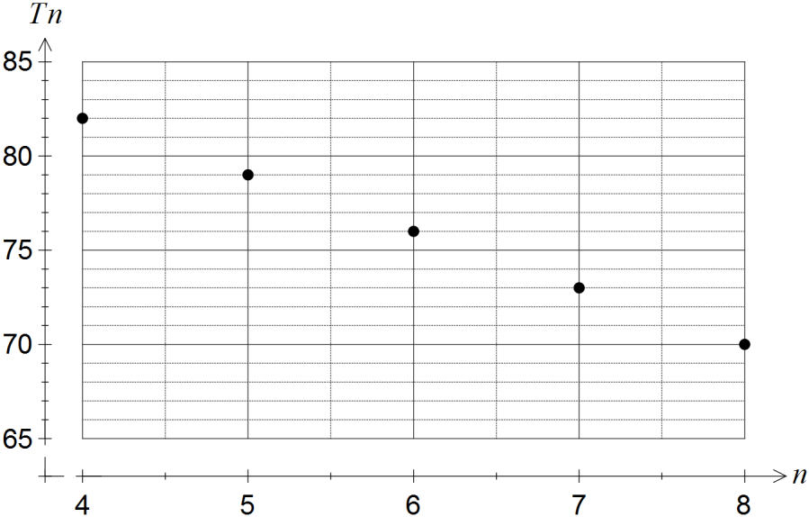

- Describe the feature of the graph that indicates the sequence is arithmetic.

- Determine
(i) T₉
(ii) T₁

- The rule for the nth term of the sequence is T_{n} = an + b. Determine the values of the constants a and b.

- Determine the smallest value of n such that T_{n} < 0 .

 | Chemistry (x) | 2 | 3 | 5 | 6 | 7 | 9 | 9
 | Physics (y) | 2 | 4 | 3 | 6 | E | 7 | 8
- (15 marks: 3, 2, 2, 4, 3, 1)
The marks for Chemistry and Physics tests (out of 10) were recorded in the table below for 6 students:
- Draw a scatterplot to represent this information

- Draw the line of best fit ‘by eye’ and hence estimate a Physic mark for the student who was unable to sit that test (score E).

- Describe the relationship

The ‘Line of Best Fit’ equation for the relationship is: y = 0.7x + 0.8
- Complete the table of residuals to 1 d.p.
 | Chemistry (x) | 2 | 3 | 5 | 6 | 9 | 9
 | Physics (y) | 2 | 4 | 3 | 6 | 7 | 8
 | Predicted Physics | 2.2 |  |  |  |  | 7.1
 | Residual | -0.2 |  |  |  |  | 0.9
- Draw a residual plot.

- Using the residual plot, decide if the data being investigated is linear or non-linear.

End of Section One

